Archetype: The Jock
Your hero is the jock: the head-strong party member whose only instincts are bravado and brute force.
As the jock, you gain the following title:

The Jock
Effects: Any time you would be frightened of a creature, you are instead taunted by the creature and you gain 1 surge.

Say the Line!
You have a number of lines you can say during this adventure. You can say these lines (or variations of them. Get creative!) at any time as a free maneuver. When you say a line at an appropriate moment:
- The Patron gains 1 temporary Stamina. If your line was in response to another hero’s line, the Patron instead gains 2 temporary Stamina. The Patron’s temporary Stamina can stack up to 13 in this way.
- You gain a bane on your next power roll.
- If you already have a bane on your next power roll, then the Director gains +1 Malice.

Lines
- “You really think some ghost or whatever is gonna mess with me?”
- “Fear’s just adrenaline. I eat that for breakfast.”
- “If something’s out there, it’s about to meet the MVP.”
- “You don’t get scared when you’re at the top of the food chain.”
- “Monsters? Please. I am the monster.”
- “I don’t run from shadows. They run from me.”
- “No one spooks the champion.”
- “I don’t tap out. Not now, not ever.”

Death of the Jock
If your hero dies during the adventure, your spirit lingers, following the party around. You cannot interact with them in any way except:
- The memory of your voice echoes in your allies’ minds. You can say your lines only in response to other hero’s lines. Heroes cannot say lines in response to your lines.
- You gain the following ability:

Body Block from Beyond
The spirit of a friend helps out with a much needed push and a heroic smile.
Magic, Ranged | Free Triggered
◣ Anywhere | ◎ One creature
Trigger: The target is force moved.
Effect: The spirit of the jock pushes against the target. You can either increase the force movement by 2 or you can reduce the force movement by 2. If you reduce the force movement, you can additionally choose to say one of your lines to deal 4 corruption damage to the target.

Survival of the Fittest
If your hero survives the adventure and continues on in other adventures, their title “The Jock” changes to the following title:

The Jock Who Lived
Effects: Any time you would be frightened of a creature, as a free triggered action, you can choose taunted by the creature instead and gain 1 surge.

Healing Potion
Thick and red, this liquid tastes of sour beer.
Keywords: Magic, Potion
Item Prerequisites: One ounce of costmary leaves
Project Source: Texts or lore in Caelian
Project Roll Characteristic: REA or INU
Project Goal: 45
Effect: When you drink this entire potion as a maneuver, you regain Stamina equal to your recovery value without spending a Recovery.

Merlu's Speaking Stone
An odd gray stone, filed into a number of flat, equally sized triangular faces, decorated fancifully.
Keywords: Magic
Effect: While you carry this stone, Merlu watches your exploits and gains Inspiration:
- Gain 1 Inspiration: In combat, a non-minion enemy becomes bleeding for the first time in that combat.
- Gain 2 Inspiration: In combat, a hero becomes bleeding for the first time in that combat.
- Gain 3 Inspiration: During a montage test, a hero rolls a natural 19 or 20 while using an intrigue or interpersonal skill.
Merlu's Inspiration resets to zero after a respite.
If a hero is within 5 squares of the stone, they can spend 1 Inspiration of Merlu's to end one condition or effect that is affecting them, or they can spend 4 Inspiration of Merlu's to regain Stamina equal to their recovery value. Each hero can regain Stamina in this way again only once until the end of the hero's next respite.

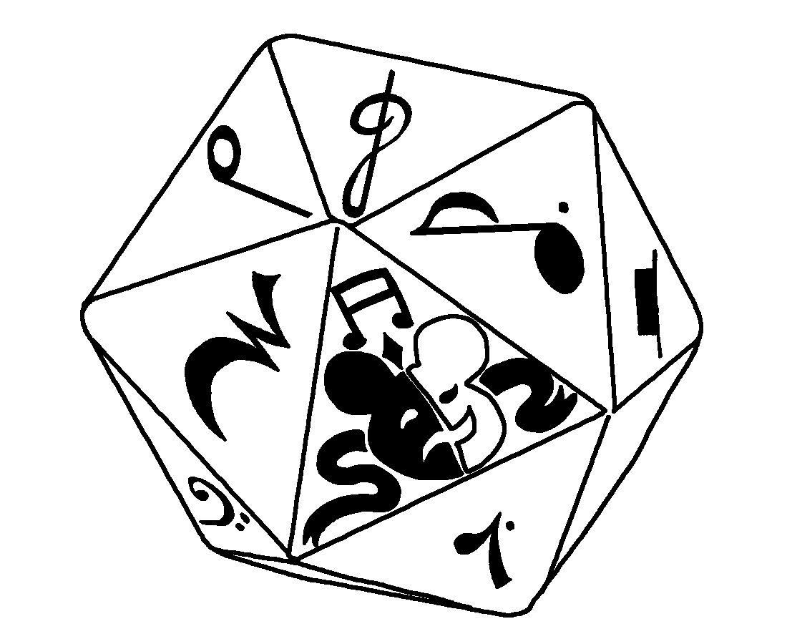

Ring of Golden Ivy
A dull, golden ring in the shape of a double helix of ivy. A small signet bears the icon of an oak tree or a hawk, depending on which company the owner belongs to.
Keywords: Magic, Ring
Effect: While you wear this ring, when an ally moves through your space, they ignore difficult terrain in the space and creatures can't make opportunity attacks against the ally triggered by their movement into or out of a square in the space.

Skullbloom, Hammer of Golden Ivy
Beautiful red roses hide in the heads of your foes. Your strikes coax them out with obsidian thorns.
Keywords: Heavy Weapon, Magic
1st Level: Any weapon ability that deals rolled damage using this weapon deals an extra 1 poison damage. Additionally, whenever you use a weapon ability using this weapon and cause an enemy to be dazed or bleeding, you can instead cause them to be bleeding or dazed, respectively.
5th Level: The weapon's extra poison damage increases to 2. Whenever an enemy takes damage from the bleeding condition, you can use a free triggered action to make a melee free strike using this weapon on them.
9th Level: The weapon's extra poison damage increases to 3. Whenever you use a weapon ability using this weapon that targets one creature and that creature is already dazed or bleeding, you can target another creature adjacent to the original target.

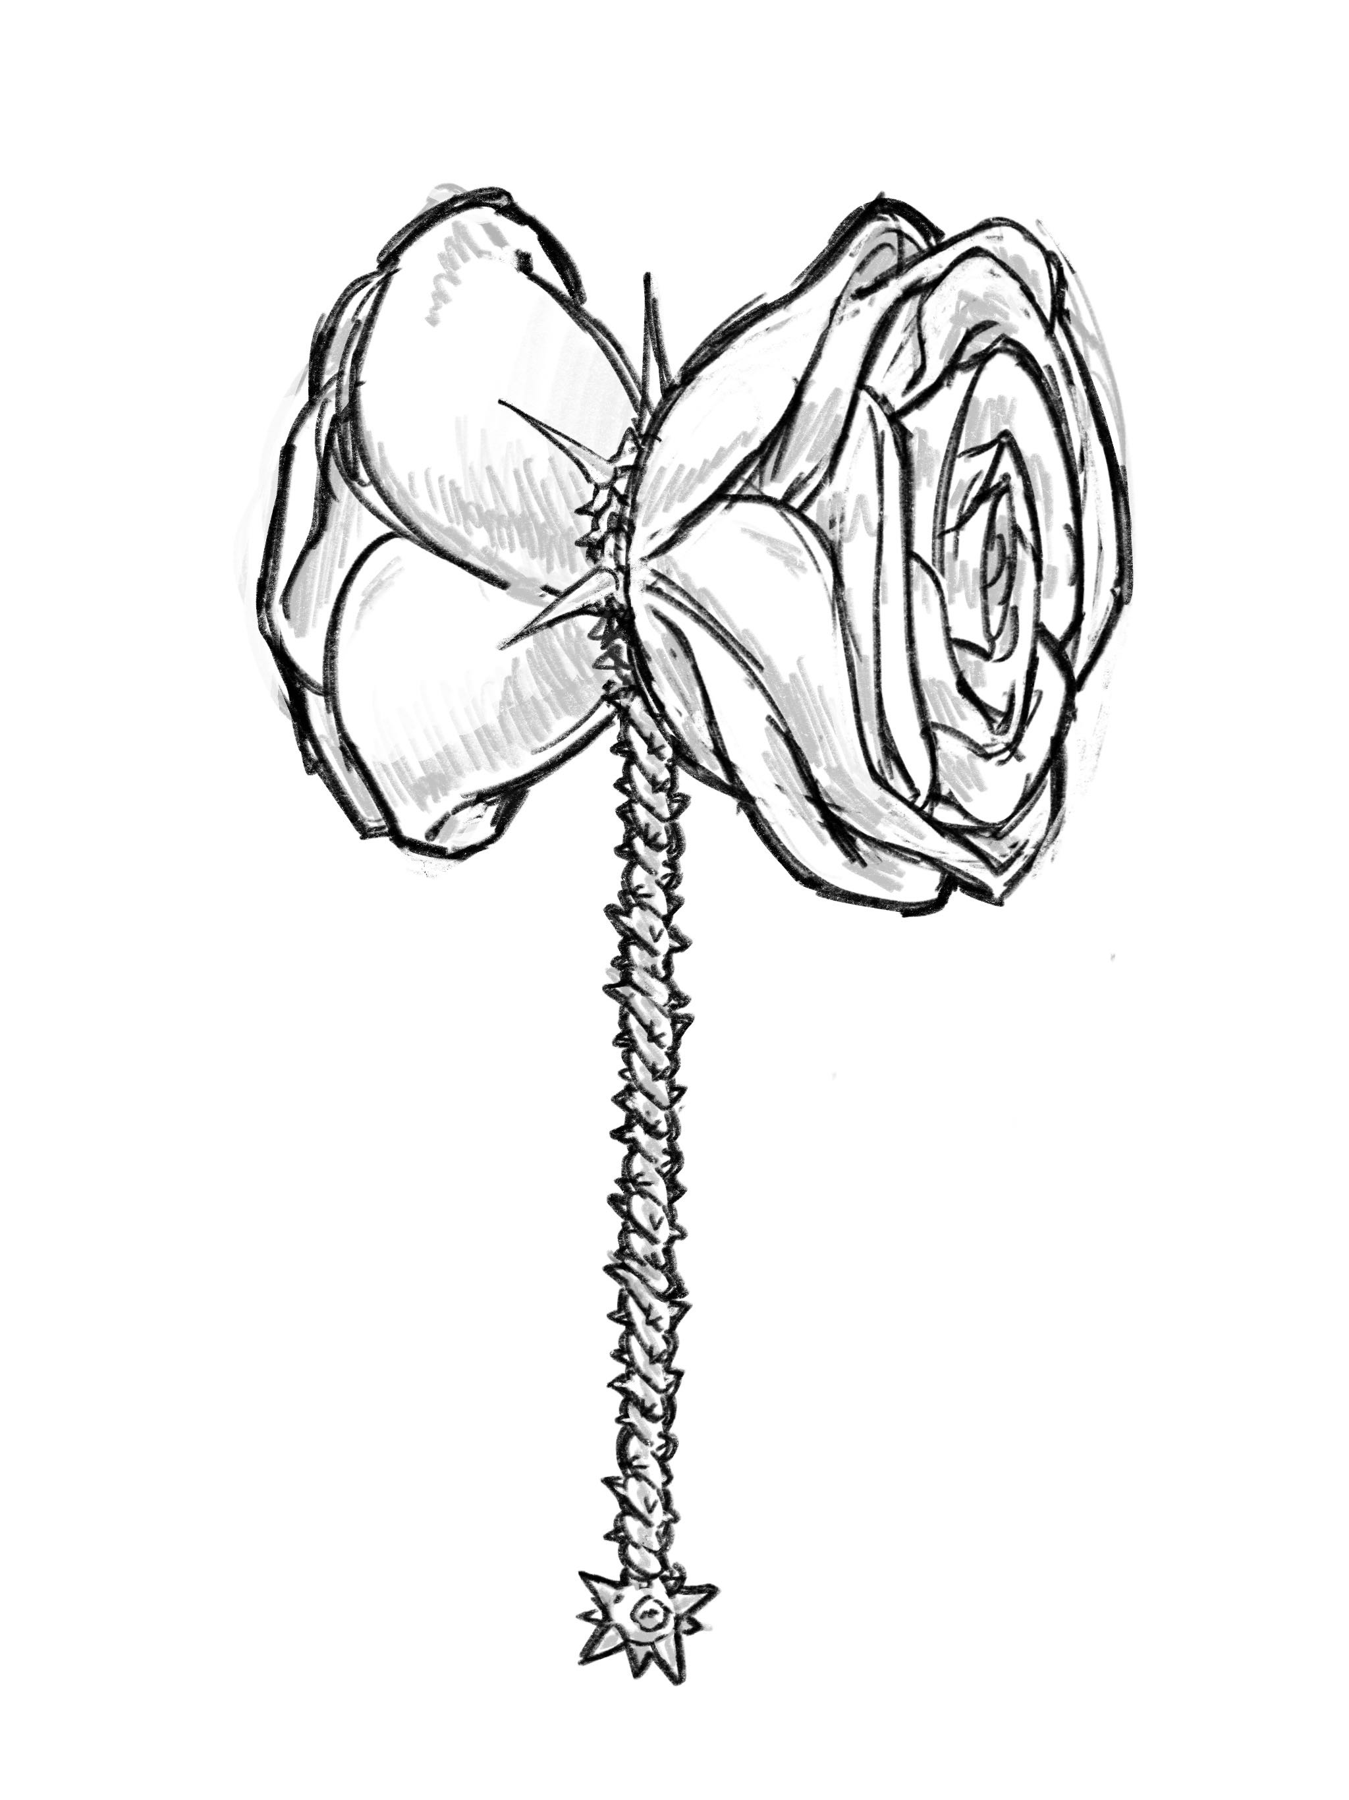
art by Jaspinplanet

Berry of the Ghost-Willow
Milky white and semi translucent, this berry features dozens of small dimples each pocketed with a seed.
Keywords: Magic
Effect: In combat, as a maneuver, eat the translucent and sour berry, taking the wind out of your lungs to instead fill your sails. Regain all your Stamina and 2 Recoveries, but you cannot use the Catch Breath maneuver again until you finish your next respite.
Outside of combat, any heroes and retainers in the party can split 5 Recoveries to regain between them. Each hero or retainer that regains Recoveries in this way cannot use the Catch Breath maneuver again until they finish their next respite.

Whisper of a Shadow Potion
Black and bubbling sludge. Are you sure this will work?
Keywords: Magic, Potion
Item Prerequisites: One pound of Arcadian bloodvine mushrooms
Project Source: Texts or lore in Kheltivari
Project Roll Characteristic: REA or INU
Project Goal: 135
Effect: When you drink this entire potion as a free triggered action at the beginning of a combat encounter, you can take three turns in a row before the first round begins. During the turns:
- You do not roll for nor otherwise gain any Heroic Resources.
- You are hidden.
- All enemies are surprised.
- Your allies cannot willingly move or use actions, even if your abilities would normally allow them to.
- You can use heroic abilities as if you were out of combat.
If you drink another of this kind of potion before your next respite, you additionally lose 5 Recoveries.

Hawklords' Quarry
Your faces are well known to Ajax's Hawklords. You carry the Jewel of Redemption, and they want it.
Prerequisites: Prevent the Hawklords from taking the boy in Part 1, Scene 3.
Effects: You gain the Hunted complication:
Benefit: You gain a skill from the intrigue skill group. Additionally, you can take the “Lay Low” respite activity. When you use it, anyone pursuing you loses track of your party's location and must start their search again.
Drawback: Each time you gain Renown, your pursuers learn your location. Unless you lay low or move to a new location, within a 1d10 days you'll be visited by a pursuer's minions, or, if you linger, a pursuer.

Marshal
I said you had twenty-four hours to leave town. That was … what, about twenty-four hours ago?
Prerequisites: Side with Alan after defeating the Hawklords and head out immediately, without respite in Part 1, Scene 4.
Effects: Choose one of the following benefits:
- Guess It's the Hard Way Then: When combat begins and you aren't surprised, the first time you take damage before taking your turn, you halve that damage.
- Heedless Pursuer: Once on each of your turns, you can use a free maneuver to deal yourself 1d6 damage that can't be reduced in any way. When you do, you ignore difficult terrain and you can increase the distance of any jump you make by 1 square, both until the end of your turn.
- Silver Shield: You have a badge granted to you by your organization. While you wear it, you gain the My Life for Yours feature from the censor class. When you use that ability, you can't spend wrath unless you have the Wrath class feature.
- Trained Tracker: You gain an edge on tests made to track criminals.

Wodewash Baiter
The fish in the Wodewash are picky eaters, but that's just fine, because you know their favorite dish.
Prerequisites: Succeed on the group skill test to help Jacqueline Mills retrieve her tools during a respite in Ivywatch.
Effects: Each time you go fishing on the Wodewash River, the first time you obtain a tier 1 outcome, the fish doesn't get away and you can continue making project rolls.

Oak Shields Company Squire
As the oak gives shade and never wavers in a gale
So will I shelter the Vale
and never waver in the storm of evil
Prerequisites: Swear the oath with The Duty of Oak.
Effects: If you have the Kit feature, regardless of your kit, you are able to equip a Shield. Additionally, choose one of the following benefits:
- Behind Me!: When you are benefiting from the Defend action, ability rolls made against allies adjacent to you have a bane.
- Comfort in Shade: When an ally adjacent to you spends a Recovery to regain Stamina using the Catch Breath maneuver, they can spend one of your Recoveries instead of their own.
- Never Waver: Gain a bonus to your stability equal to twice the number of ally heroes adjacent to you.

Thorned Gauntlets Company Squire
As thorns draw blood from those who covet the rose
So will I draw blood from fiends who covet the Vale
Prerequisites: Swear the oath with The Duty of Thorns.
Effects: Choose one of the following benefits:
- Draw Blood!: As part of the movement of the Charge action, you can move 2 extra squares. Additionally, when you obtain a tier 3 outcome with a melee free strike, the target is M < average bleeding.
- Thorn in Their Side: You gain an edge on your ability rolls made as part of opportunity attacks.
- Fledgling: You gain the Familiar perk. Your familiar is the spirit that has taken the form of a small bird of prey and can fly.
The spirit uses the familiar stat block.
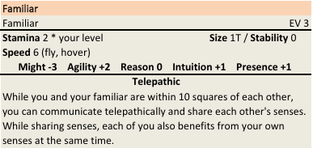
The familiar can hold small objects in their mouth or claws, but can't perform activities that would typically require hands (opening a door, unrolling a scroll, and so forth). They can't harm other creatures or objects. They can flank in combat, but only with you.
If your familiar is destroyed, you can restore them as a respite activity, or by spending a Recovery as a main action to bring them back into existence in an unoccupied space adjacent to you.

Doomed
I don't know what it meant, but when I watched her die, I saw a vision. I watched her die and saw my own death. Am I losing my mind?
Prerequisites: Bleddyn is your ally in Scene 10.
Effects: You aren't destined for a meaningful death, but you still might achieve one. When you're reduced to 0 Stamina but remain conscious, you can become doomed. If you do, you can't regain Stamina, you automatically obtain a tier 3 outcome on tests and power rolls, and you don't die until your Stamina reaches the negative of your Stamina maximum. At the end of the encounter, you die.

